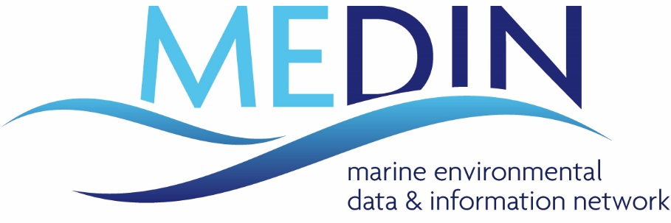

MEDIN Partnership Agreement

INTRODUCTION
1.1 This Partnership Agreement acknowledges the importance of bringing together members of the UK marine community from all sectors (including public and private organisations), to improve access to and management of marine environmental data and information. It acknowledges the importance of facilitating information sharing and working partnerships between organisations that have data and expertise in different aspects of marine environmental data and information.
1.2 This Partnership Agreement sets out an agreed common set of responsibilities, which when acted upon will facilitate access to, and management of marine environmental data and information; it sets out the roles and responsibilities of MEDIN partners. It does not create any legal obligations or a contract between MEDIN partners, but records a level of co-operation between them.
1.3 This Partnership Agreement does not imply any transfer of Intellectual Property Rights or Copyright. Any transfer would require a separate agreement between the organisations.

GENERAL INTENTION
2.1 To improve access to and management of Marine Environmental Data and Information through the cooperative efforts of partners that may own or manage marine environmental data / information and / or possess relevant expertise, and thereby prevent the duplication of effort in data collection, and ensure the widest and most efficient possible use of the UK’s valuable marine data and information resources.
2.2 To aid the wider dissemination of information about marine environmental data and an information management strategy within the partner organisations.

ROLE OF MEDIN PARTNERS
3.1 MEDIN will only be successful if all partners take a pro-active role in the development and implementation of the work programme.
3.2 Similarly the success of MEDIN relies on partners offering “in-kind” support in terms of staff effort, meeting the costs of travel to attend to meeting, and use of partners’ resources.
3.3 Partners are to nominate members of their staff to attend workshops and meetings (at least one per year), and to contribute to the activities of working groups.
3.4 Member organisations will endeavour to ensure that all relevant personnel within their organisation are aware of this agreement. They will adopt and evolve internal practices so that the “best practice” guidelines detailed in section 4 below are adopted as standard operational practice.
3.5 Partners agree to provide annual reports, through a standardised questionnaire / proforma on how they are meeting these aims within their own organisations. They may use this process to record the level of “In-kind” support that has been provided to MEDIN.
3.6 Unless otherwise established by specific agreement, the Intellectual Property Rights or copyright of the data owned by each member will remain with them and all related issues dealt with by them. Existing third party Intellectual Property Rights are unaffected by this agreement. In addition, subject to any prior rights and to the rights of third parties, all MEDIN partners have a right to freely use and disclose the Project Results for all purposes at no charge to the partner.

“Best Practice” for Management of Marine Data
4.1 Standards: Apply and documenting recognised Quality Control procedures at all stages of data collection, processing and archiving.
4.2 Metadata: Generate and maintain metadata records for all marine data in MEDIN format and publish these metadata to MEDIN and the wider community.
4.3 Archiving: Lodge all relevant marine data of long-term interest with DACs recognised by MEDIN (subject to ownership agreements) – can require restricted access if required. In return, DACs undertake to ensure data are always freely available to the original supplier.
4.4 Data Access Policy: Establish in clear terms policy with regard to data ownership, licensing and access as they apply to individual data sets. Conform with various data policies as they relate to individual data sets (e.g. Freedom of Information, Environmental Information Regulations, Public Sector Information regulations, Intergovernmental Oceanographic Commission -IOC, World Meteorological Organisation - WMO).
4.5 Acknowledging Data Source – Partners will acknowledge the source of any data they access through the framework, and will respect data policy as requested by the owner.
4.6 Cementing & Promoting Best Practice: When letting data collection contracts ensure that:
- appropriate standards are applied and recorded,
- that metadata are generated in the MEDIN recommended format,
- that provision is put in place for long term curation,
- that IPR and terms for third party use are clearly defined.
In support of this MEDIN will work to establish a model “data clause” with implementation guidelines and will encourage its application in data collection contracts.

RESOLUTION OF PROBLEMS
5.1 Should it appear that any element of this Partnership Agreement cannot be met; a meeting of the MEDIN Executive Team will explore and identify alternatives. Any unresolved disputes or difficulties will be taken to the MEDIN Sponsors’ Board.
5.2 If any member considers it no longer appropriate to continue with the agreements set out in this Partnership Agreement, it shall be entitled to give 1 month’s notice of termination to all members. At the end of that period their responsibilities to this Partnership Agreement will cease.

In this context “freely” available means without restriction on use, but in some cases a reasonable cost of recovery fee may be charged, if agreed between the DAC and data supplier.

